PERSONAL INFORMATION
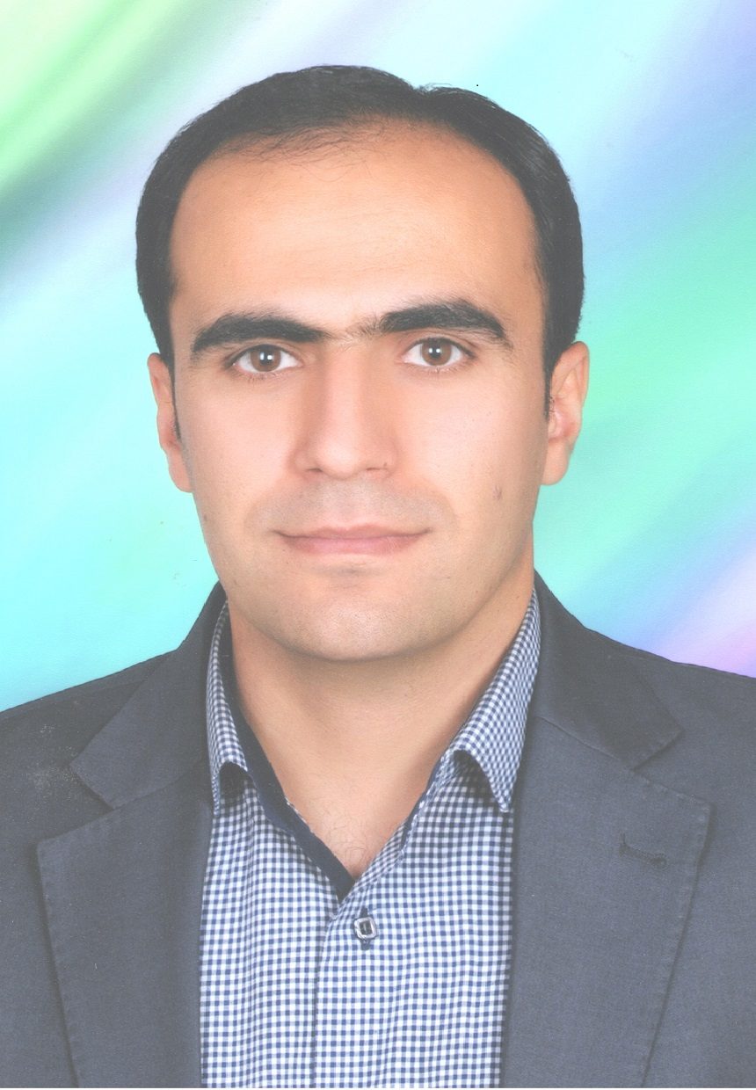

Nursing and Midwifery Faculty, Dolatabad Blv, Kermanshah, Iran.

+98-8338250815 +98-9127368595

Vahid.gh13@gmail.com
Sex Male | Date of birth 21/March/1983 | Nationality Iranian

WORK EXPERIENCE

From 2019/12/02 to current  From 2015/08/23 to 2019/12/21  From 2013/ 12/22 to 2015/08/ 20  From 2009/10/19 to 2012/10/18  From 2006/10/01 to 2009/08/23 | Assistance Professor  Nursing and Midwifery School, Kermanshah University of Medical Sciences, Kermanshah.  Emergency nurse
Rozbeh Psychiatric Hospital/ Tehran
Intensive Care Unit Nurse and Emergency nurse
Sasan Hospital, Tehran
Lecturer
Nursing and Midwifery School, Ilam University of Medical Sciences, Ilam.
Emergency Nurse
Madaen Hospital

EDUCATION AND TRAINING

From 2013/02/ 02 to 2019/02/01  From 2006/09/23 to 2009/09/08  From 2002/09/ 23 to 2006/07/22 | Ph.D Health in Disasters and Emergencies  Public Health School of Tehran University of Medical Sciences, Tehran, Iran.
Dissertation: Exploring an Ethical Framework for Decision Making in Disaster Triage in Iranian Context
Dissertation Advisors: Dr Ali Ardalan, Dr Armin Zareyian, Dr Dan Hanfling
M.S in Nursing
University of Social Welfare and Rehabilitation, Tehran, Iran
Dissertation: The effect of earthquake preparedness program (training and maneuver) on the readiness of nursing staff of Razi Psychiatric Hospital in responding to a possible earthquake in 2008
Dissertation Advisors: Dr Hamidreza Khankeh

Bachlore of Nursing
Nursing and Midwifery School of Tehran University of Medical Sciences, Tehran, Iran.

PERSONAL SKILLS

Mother tongue(s) | Persian
English | UNDERSTANDING |  | SPEAKING |  | WRITING
English | Listening | Reading | Spoken interaction | Spoken production
Replace with language | Independent | Independent | Independent | Independent | Independent

Communication skills | - Good communication skills gained through my experience as an emergency nurse and Ph.D researcherpe  - A good triage officer  - A patient and master emergency nurse specially in psychiatric and general hospital

Organisational / managerial skills | - Coordination and leadership (responsible for a team to develop three research projects)

Job-related skills | - Good internet search to find related content related to concerned topic  - Good project manager for guiding two research projects with Iran Ministry of Health and United Nation Population Fund

Digital competence | SELF-ASSESSMENT
Digital competence | Information processing | Communication | Content creation | Safety | Problem solving
 | Independent user | Proficient | Proficient | Basic user | Proficient
Levels: Basic user - Independent user - Proficient user
Digital competences - Self-assessment grid
 | Replace with name of ICT-certificate(s)
Replace with your other computer skills. Specify in what context they were acquired. Example:
- Good command of office suite (word processor, spread sheet, presentation software)
- Good command of searching research evidences

Other skills | Good Teacher and Consoler

Driving licence | B

ADDITIONAL INFORMATION

Articles
Publications  Projects  Conferences  Memberships  Courses | - Ghafari S, Khankeh HR, Ghanbari V, Ranjbar M. The study of affiliated hospitals preparedness to University of Welfare and Rehabilitation Sciences for unexpected disasters in 2011. Quarterly Scientific Journal of Rescue and Relief. 2012;4(3):0-.  - Ghanbari V, Ardalan A, Salari S, Ostadtaghizadeh A, Talebi F, Abbaszadeh R, et al. Prioritization Community Selection Criteria for Community-Based Disaster Risk Reduction Intervention. Hakim Research Journal. 2019;22(2):130-7.  - Ghanbari V, Ardalan A, Zareiyan A, Nejati A, Hanfling D, Bagheri A. Ethical prioritization of patients during disaster triage: A systematic review of current evidence. International emergency nursing. 2019;43:126-32.  - Ghanbari V, Maddah S, Khankeh H, Karimloo M. The effect of a disaster nursing education program on nurses’ preparedness for responding to probable natural disasters. Iran Journal of nursing. 2011;24(73):72-80.  - Ghanbari V, Zareiyan A, Nejati A, Hanfiling D, Ardalan A. Ethical Patient Prioritization in Disaster Triage: A Protocol for a Systematic Review. Health in Emergencies and Disasters. 2019;4(3):113-8.  - Kafami F, Mousavi S, Ghanbari V. Survey the relationship between delegation and job satisfaction in nurses. Journal of Health Promotion Management. 2012;1(2):29-34.  - Khajehaminian MR, Hosseini Boroujeni SM, Ghanbari V, Delkhosh M. Breastfeeding in disasters: A reminder for policymakers. Journal of Disaster and Emergency Research. 2019;2(2):110-4.  - Ladani F, Shokrollahi N, Ghanbari V, Nahidian M, Hesaraki M. Health related quality of life (HL-QOL) of nurses working in a urban hospital in isfahan: A cross-Sectional study. Prensa Medica Argentina. 2017;103(6).  - Ramim T, Mousavi SQ, Rosatmnia L, Bazyar A, Ghanbari V. Student knowledge of Testicular cancer and self-examination in a medical sciences University in Iran. Basic & Clinical Cancer Research. 2014;6(3):7-11.  - Rasouli p, Shobeiri f, Cheraghi f, Rasouli r, Ghanbari V. Study of the relationship of anxiety and depression in third trimester pregnancy on growth index of neonates and preterm delivery. Journal of Pediatric Nursing. 2016;2(4):1-9.  - Rostamnia L, Ghanbari V, Shabani F, Farahani A, Dehghan-Nayeri N. Evidence-Based Practice for Cardiac Intensive Care Unit Nurses: An Educational Intervention Study. The Journal of Continuing Education in Nursing. 2020;51(4):167-73.  - Rostamniya L, Ghanbari V, Kazemnejad Leili E, Pasha A, Karimi Rozveh A, Pariyad E. Factors associated with nurses' participation in clinical decision making. Iran Journal of Nursing. 2014;27(88):66-76.  - Seifi A, Dehghan-Nayeri N, Rostamnia L, Varaei S, Sari AA, Haghani H, Ghanbari V. Health care–associated infection surveillance system in Iran: Reporting and accuracy. American journal of infection control. 2019;47(8):951-5.  - Ghanbari V, Ardalan A, Nejati A, Rostamnia L, Mousavi G. Emergency numbers accessibility for disabled peoples': Case of the Islamic Republic of Iran. Journal of Emergency Management (Weston, Mass.). 2020 Nov-Dec;18(6):541-544.  Books  - Ardalan A, Ghanbari V, Kolivand P, Banar A, Saberinia A, Sarvar M, et al. Health system Lessen Learned In devivering Health Service to Arbaeein 2015. Tehran: Azar Barzin; 2016.  - Khankeh HR, Nasiri A, Ghanbari V. Basic Senario of Health system in responding to disaster. Tehran: University of Social Welfare and Rehabilitiation; 2016.  - Ghanbari V, Ardalan A. Ethics in disaster. In: Ardalan A, Khankeh HR, Mehrabi Tavan A, Nejati A, Masomi G, Hajebi A, editors. Text book of Health in Emergencies and Disasters. 1. Tehran: Meher Matin; 2015. p. 8.  - Framework for Reproductive Health Services in Emergencies and Disasters in I.R. Iran, 2017_2021.  - Design, implementation and evaluation of a community-based disaster risk management initiative in Kerman  - Ghanbari V, Ardalan A. Developing an Ethical Framework of Decision Making in Disaster Triage in Iranian Context. 9th International Congress on Health in Emergencies and Disasters; Tehran2018.  - Ghanbari V, Ardalan A. Framework for Reproductive Health Services in Emergencies and Disasters in I.R. Iran, 2017_2021. 9th International Congress on Health in Emergencies and Disasters; Tehran2018.  - Ghanbari V, Ardalan A, Hossini Brojeni M. Health system lesson Learned in Prepareing to Arbaeein 1394. 8th International Congress on Health in Emergencies and Disasters; Tehran2016.  - Ghanbari V, Khankeh HR. the effect of Preparedness Program on Nurses readiness in response to disaster. 4th International Congress on Health in Emergencies and Disasters; Tehran2009.  - Ghanbari V. Ethical Issues of Triage in disaster. The Fourth Congress of Men; Tehran2020.  - Iranian Nursing Scientific Association  - Iranian Scientific Association for Disaster Management  - Prehospital Trauma Life Support (PHTLS), Tehran, 2015.  - Health Emergencies in Large Populations (HELP), Tehran, 2016.  - Research in Disaster

ANNEXES

